1.     List all customers and the products they ordered with the order date. (Inner join)

**Tables used:** customers, orders, order_details, products

**Output should have below columns:**

    companyname AS customer,

    orderid,

    productname,

    quantity,

orderdate

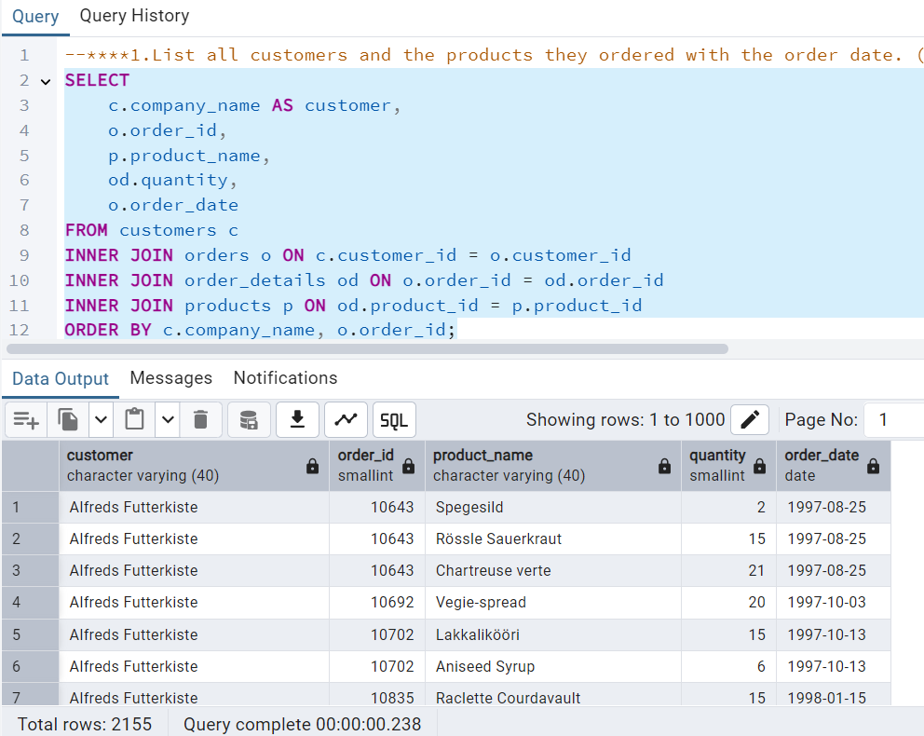

2.     Show each order with customer, employee, shipper, and product info — even if some parts are missing. (Left Join)

**Tables used: orders, customers, employees, shippers, order_details, products**

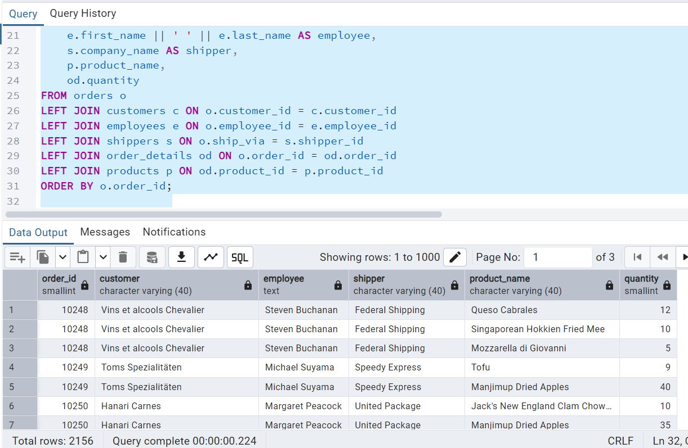

3.     Show all order details and products (include all products even if they were never ordered). (Right Join)

**Tables used: order_details, products**

**Output should have below columns:**orderid,  
productid,  
quantity,  
productname

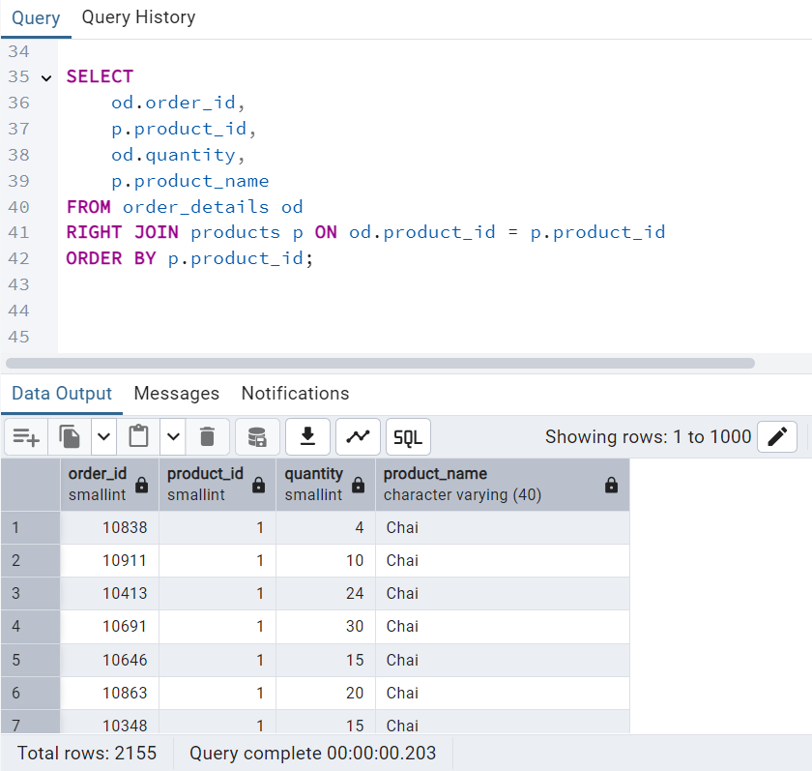  
  
  
  
  
  
  
  
  
  
  
  
  
  
  
  
  
  
  
  
  
  
  
  
4. List all product categories and their products — including categories that have no products, and products that are not assigned to any category.(Outer Join)

**Tables used: categories, products**

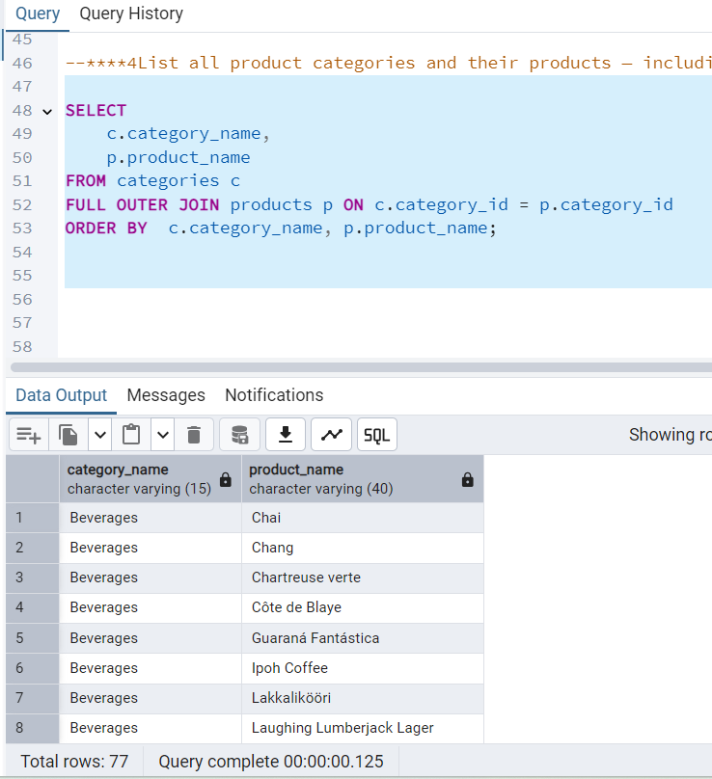

5. Show all possible product and category combinations (Cross join).

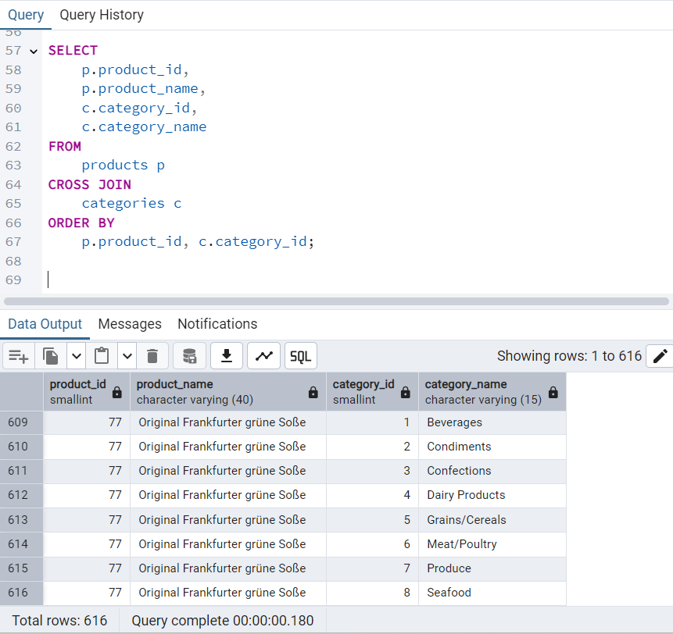

6. Show all employees and their manager(Self join(left join))

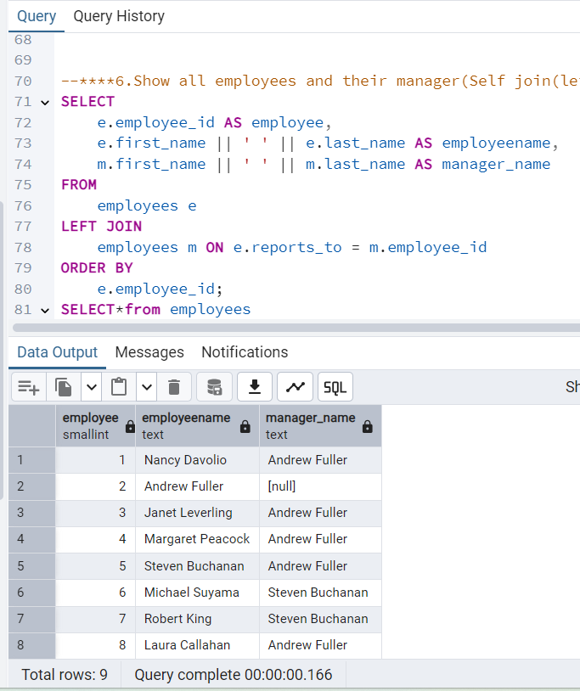

7. List all customers who have not selected a shipping method.  
**Tables used:** customers, orders  
**(Left Join, WHERE o.shipvia IS NULL)**

